USER GUIDE:
Managing Lock Desk Queues in the FLEX PPE
—

The Lock Desk manages initial locks and post lock changes in the Lock Desk queue inside the FLEX PPE. The Lock Desk queue can be accessed by logging into FLEX directly.

Select Lock Desk in the menu on the left hand side of the page.

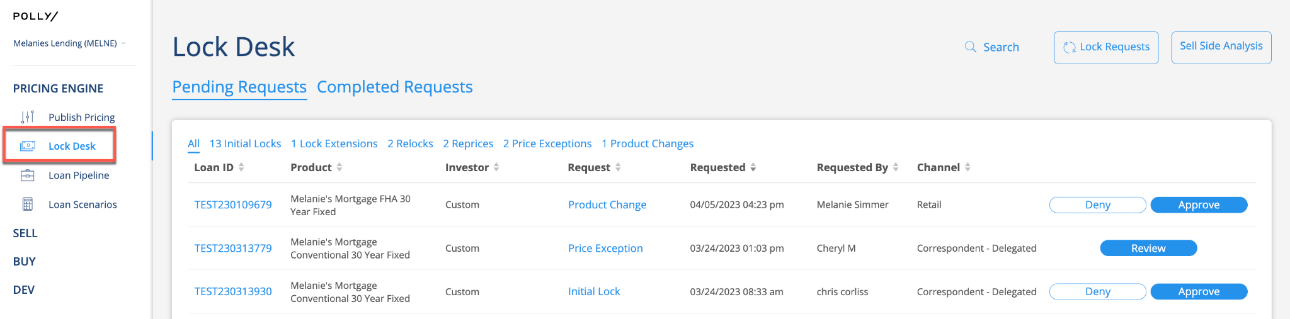

The Lock Desk queue has multiple filter options. There are two main views, Pending Requests and Completed Requests.

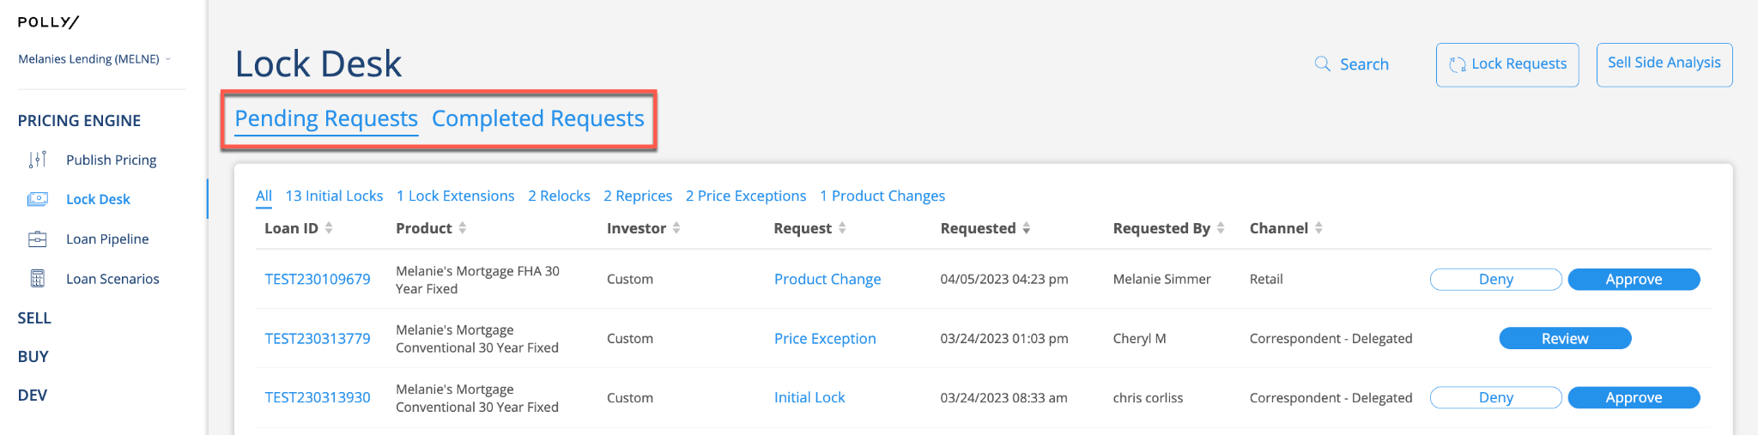

Under each Lock Desk view, there are additional views that will display each type of request.

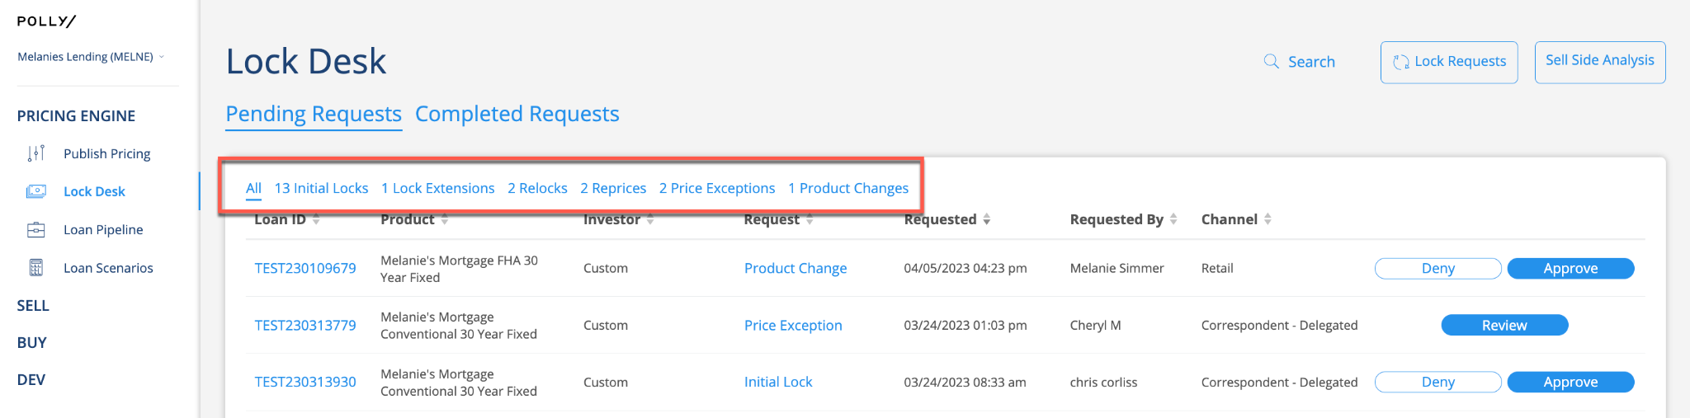

The queue has a filter that will display Price Exceptions that are pending Approver decisions, in the event a Lock Desk override needs to take place. Once the Approver has decisioned the Price Exception, it will display in the Pending Requests default queue view.

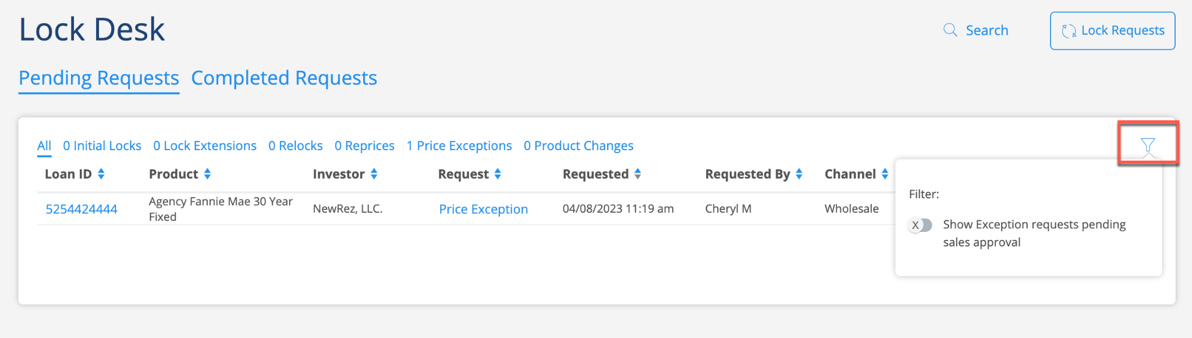

The headers below the filters will order the loans in ascending or descending order when selected.

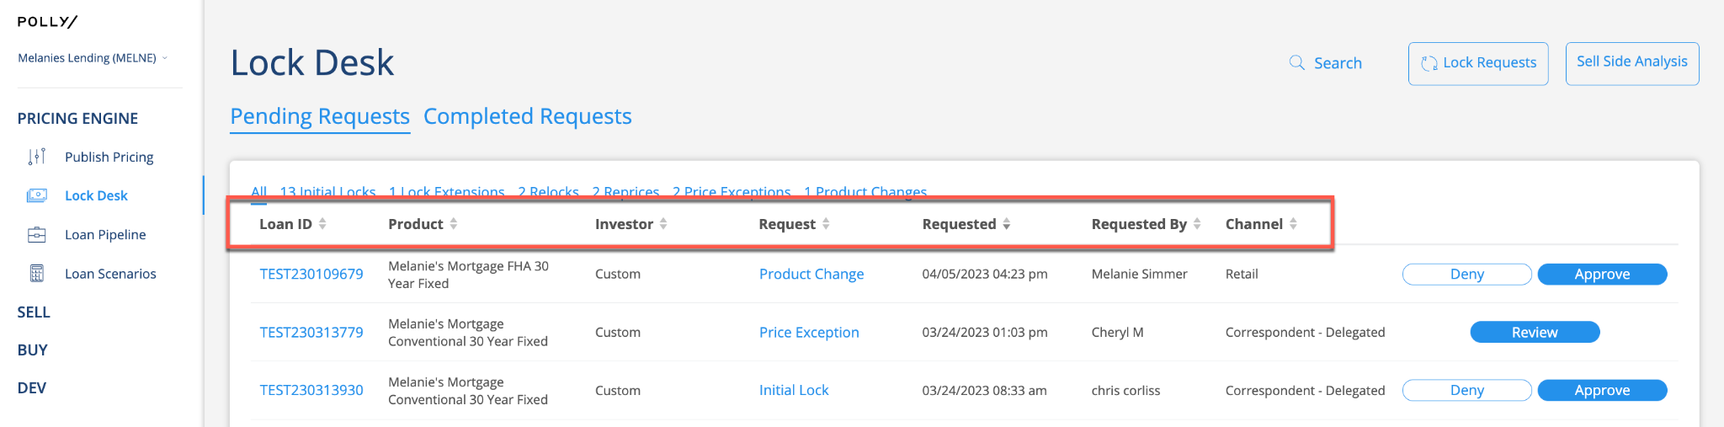

Pending Requests can easily be approved or denied by selecting the buttons on the right side of the screen, next to the Loan ID. These requests can also be approved or denied by selecting the Loan ID or the Request link to view more details surrounding that request.

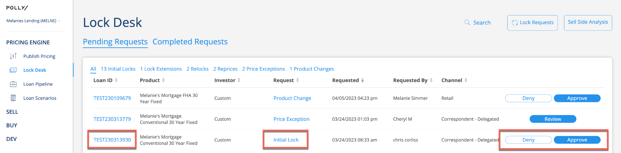

When selecting the request link, the user will land in the details page for that transaction. The transaction can be approved or denied using the buttons in the top right corner of the page.

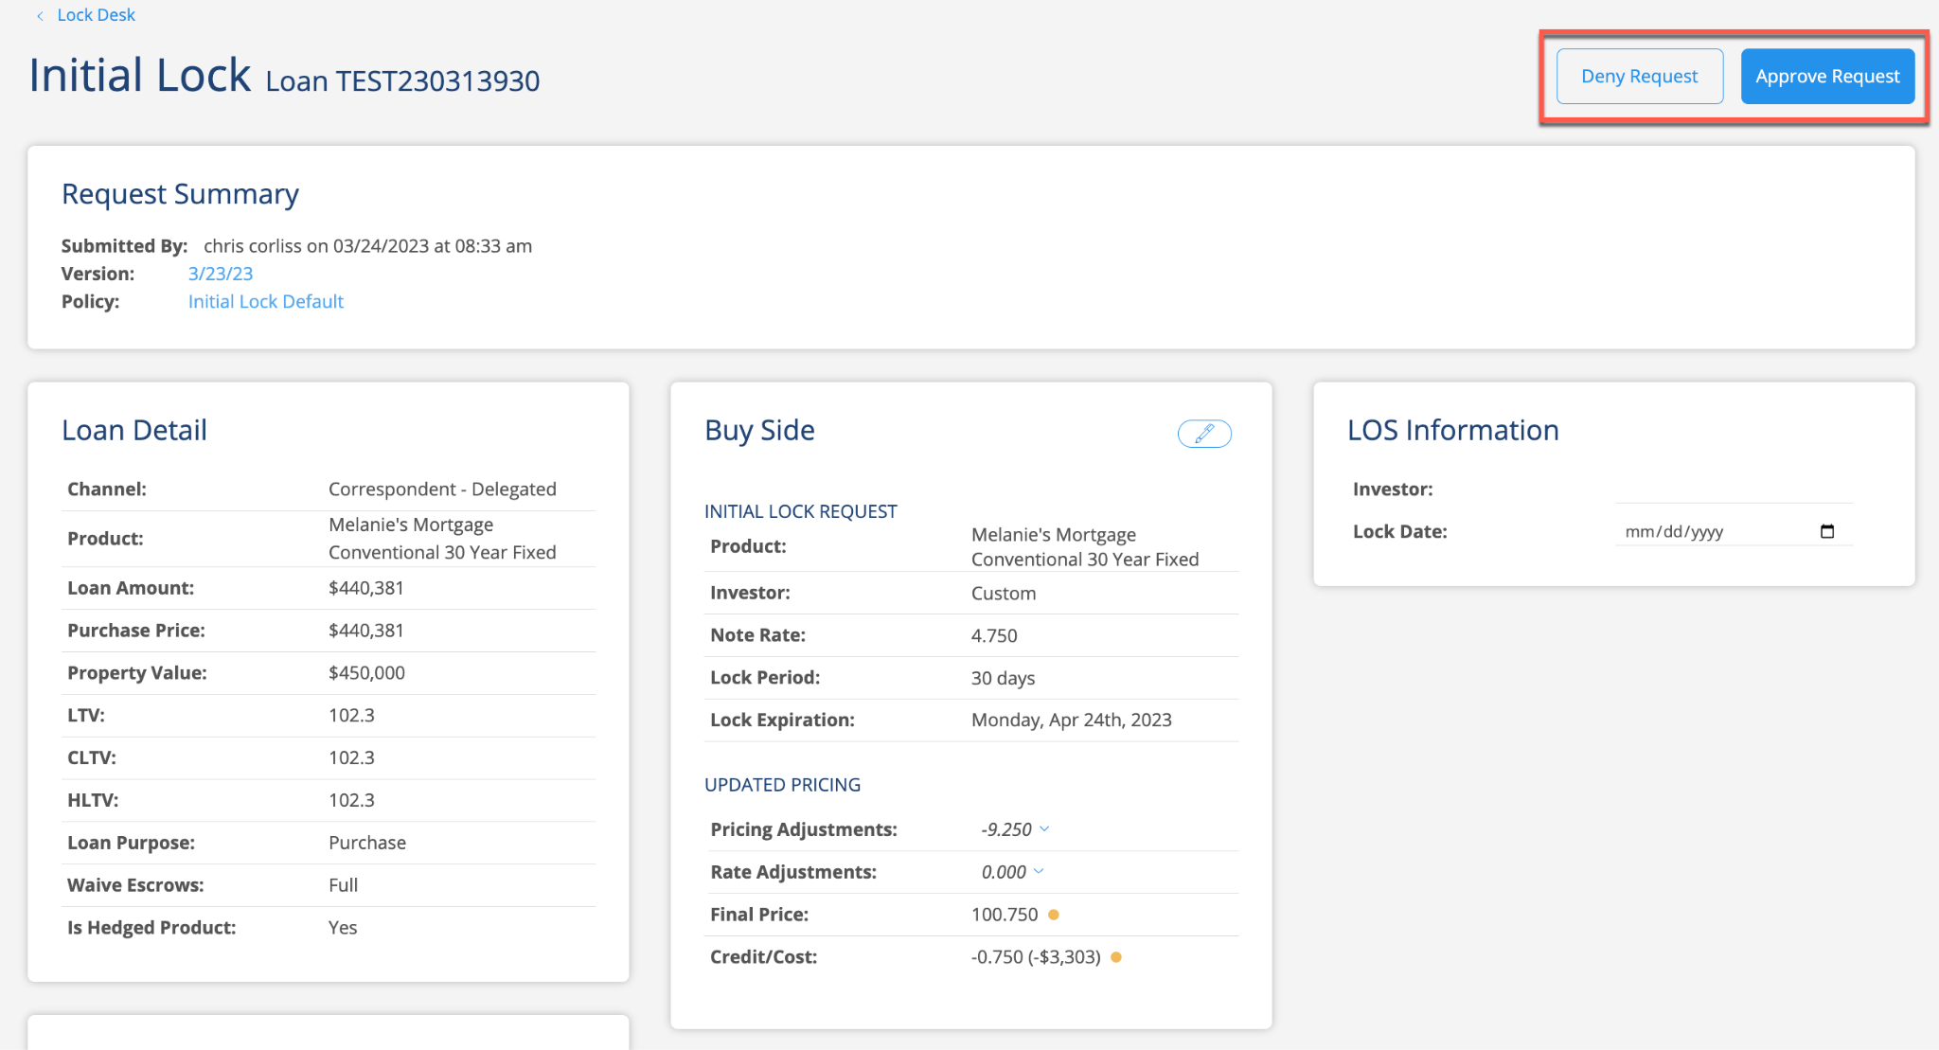

The buy side data can also be edited prior to approving the transaction by selecting the pencil icon in the Buy Side card.

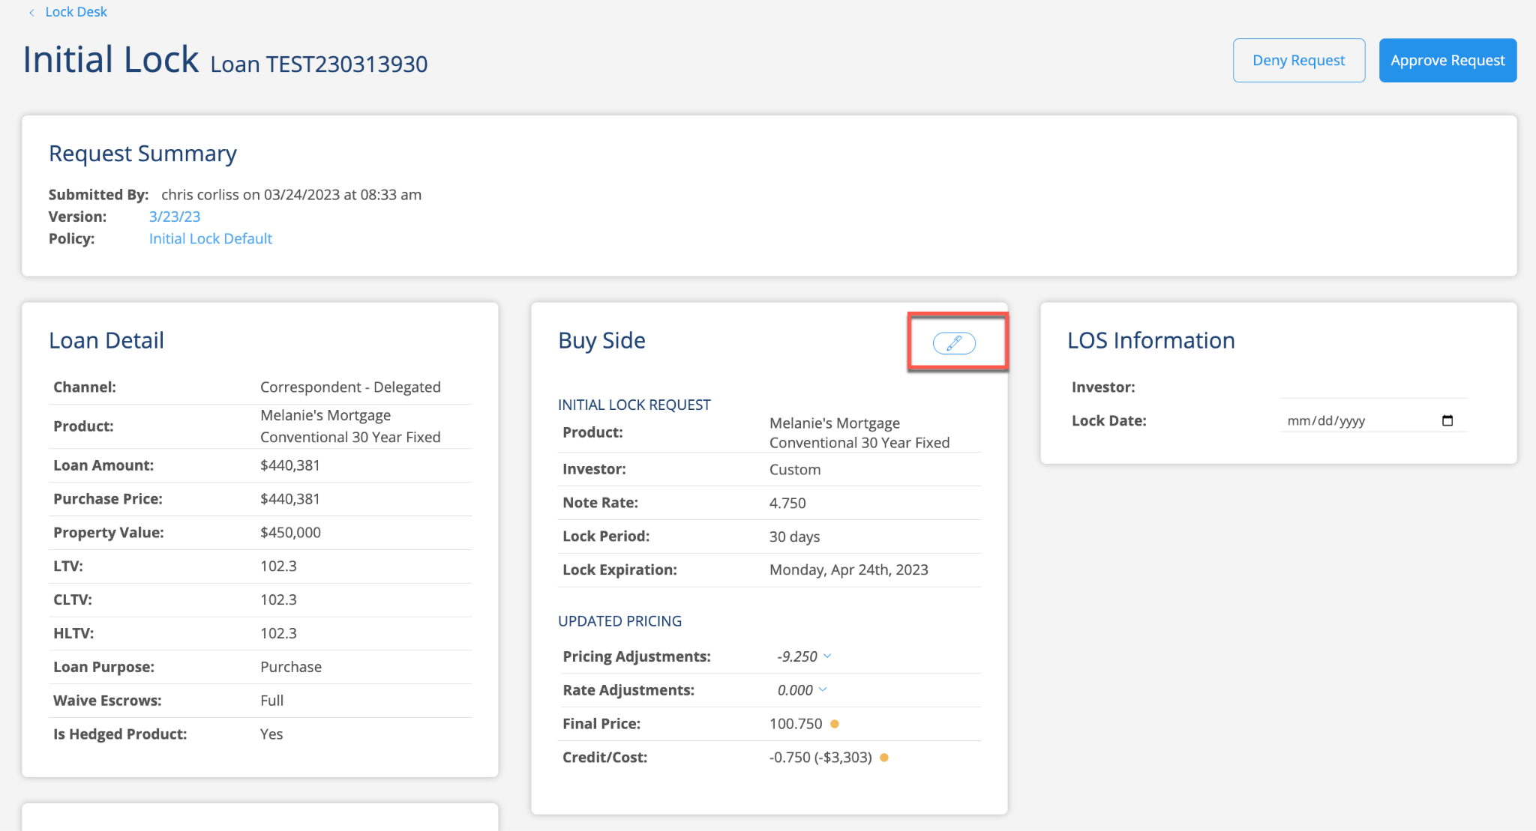

When selected, several fields are available to be edited.

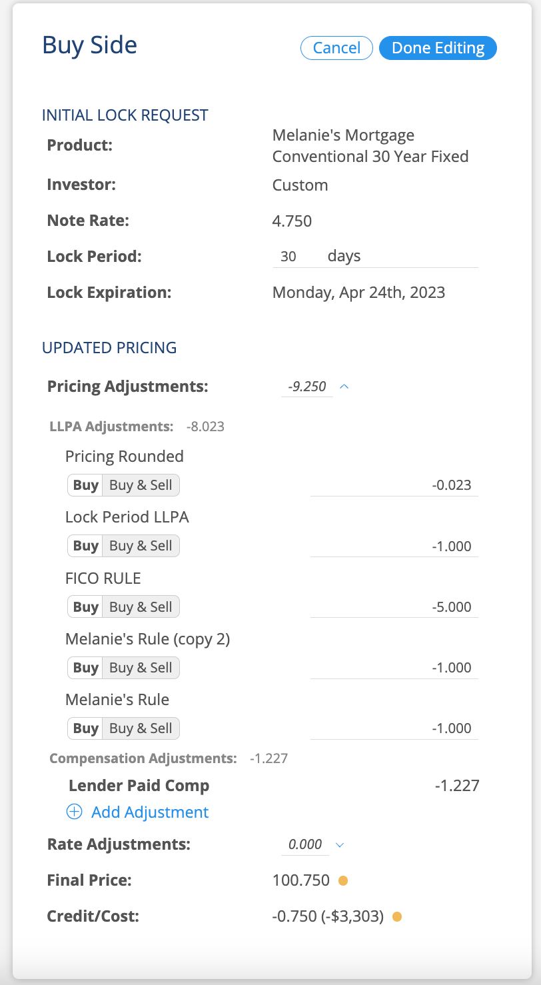

To edit the final price, select the Add Adjustment option.
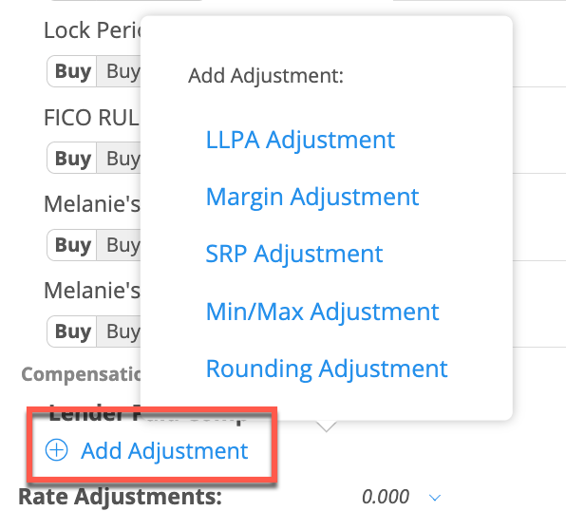

Note: When adjusting the price, always offset the price using the add adjustment option, otherwise on the next transaction the manual adjustment change will not be retained.

Once complete, select Done Editing and then Approve Request. The updated information will be sent back to the LOS.

Note: Please make sure to exit the loan so the updated data writes back to the LOS. The Writeback Status column will display Success once the transaction has been successfully sent back to the LOS.

