USER GUIDE:
How to Request a Reprice in the FLEX PPE
—

Select FLEX as the PPE option inside the LOS to launch into FLEX with the selected loan.

Upon log in to FLEX, the user will see the Reprice option to reprice the loan based on any data changes.

Note: Any data changes inside the LOS will automatically flow into FLEX.

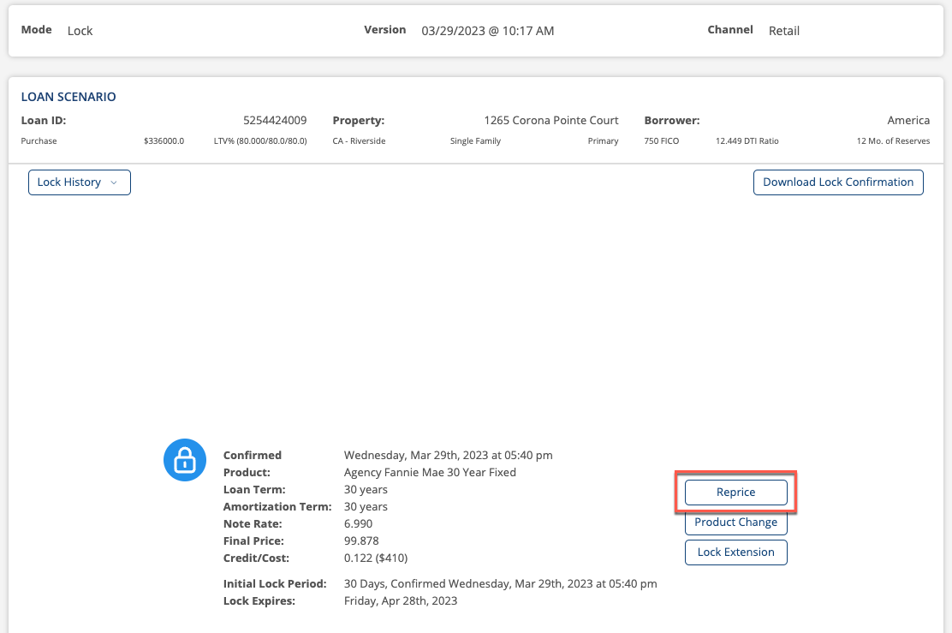

Select Reprice and the user will be directed to the search results with the updated data, eligibility, and pricing information.

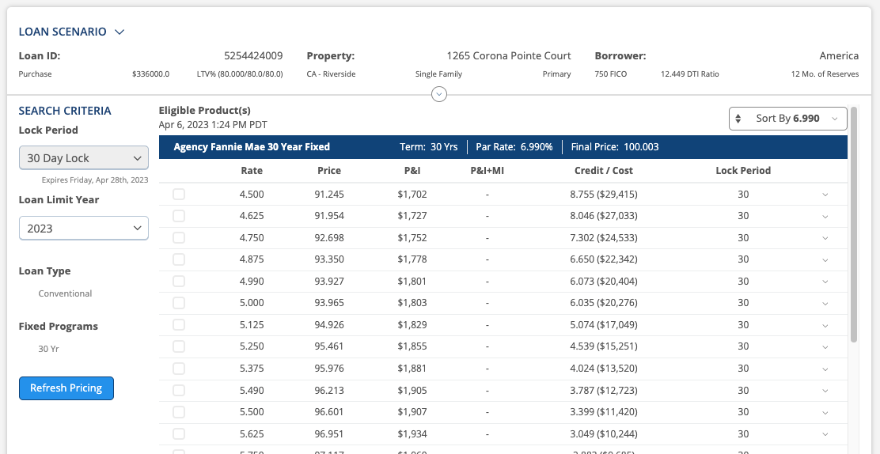

Select the down arrow toward the middle-top of the page to enable the user to see the Pricer UI and any updated data that was mapped into FLEX.

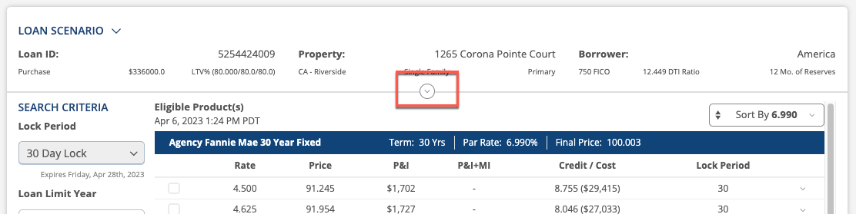

Users can make additional changes inside the FLEX for fields that are not locked down.

Note: If a field is locked down, the user will need to exit FLEX and make the updates inside the LOS and then launch back out to FLEX to price the loan with the updated values.

Once the fields above are updated, click Refresh Pricing to see updated price results.
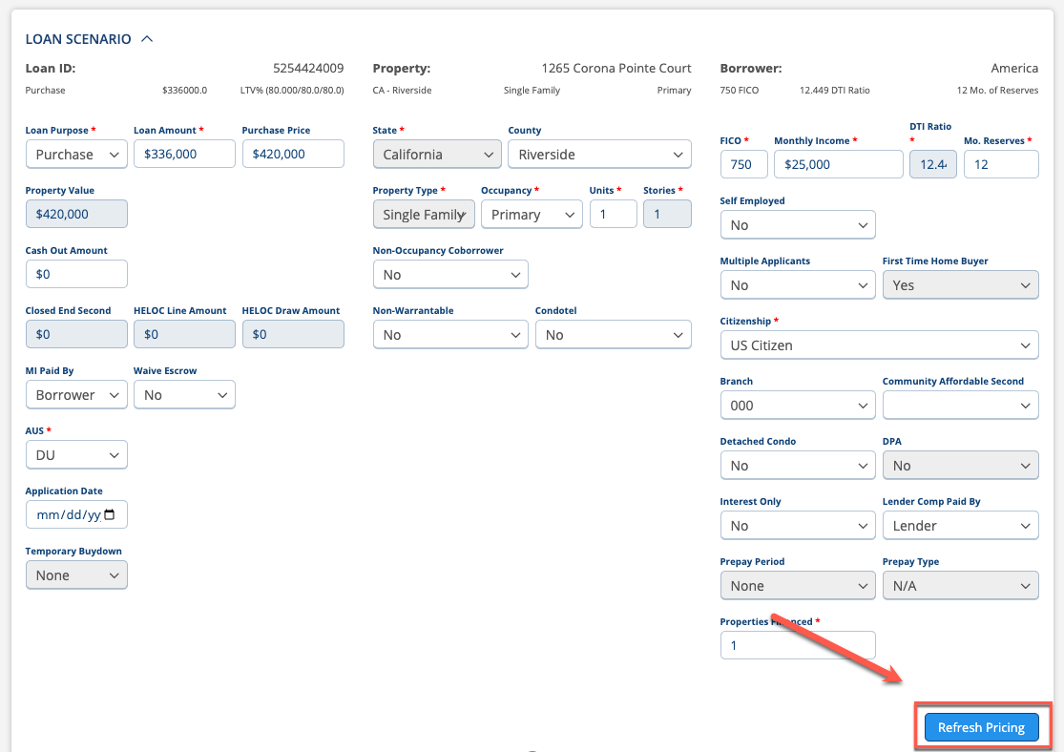

In the Results, the user will select the applicable rate and select the Select Rate button.

Note: FLEX will auto-select the rate that was previously selected when the loan was locked.

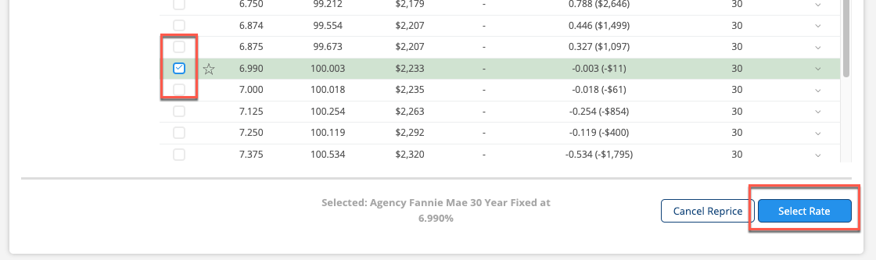

After selecting the Select Rate button, the user will be directed to the next page where they will see an overview of what the Initial Lock data was, the Current Lock data, and the Lock After Reprice data.

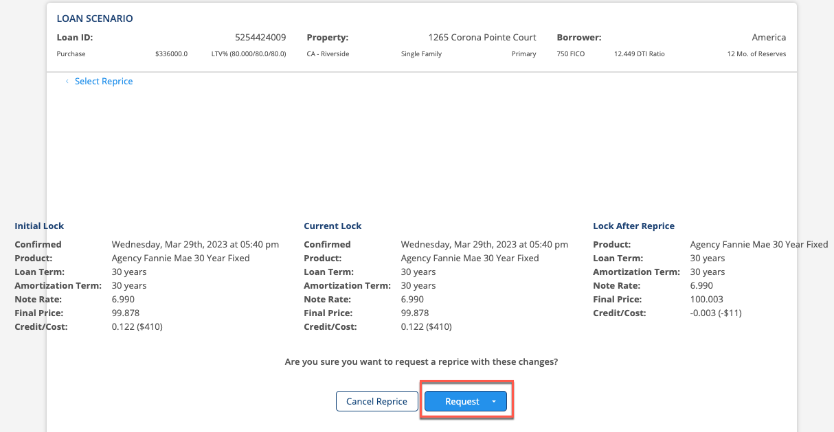

Users will select the Request button to request the Reprice. If reprice policies are configured to be auto accepted, the Reprice will be automatically accepted and the updated data will be sent back to the LOS.

Note: Please make sure to exit the loan so the updated data writes back to the LOS.

