USER GUIDE:
How to Request a Price Exception in the FLEX PPE
—

Select FLEX as the PPE option inside the LOS to launch into FLEX with the selected loan.

Price Exceptions can be requested during the initial lock and/or post lock.

During the initial lock, when the user lands on the page to request the lock, they can select the arrow option and select Request Lock with Exception.

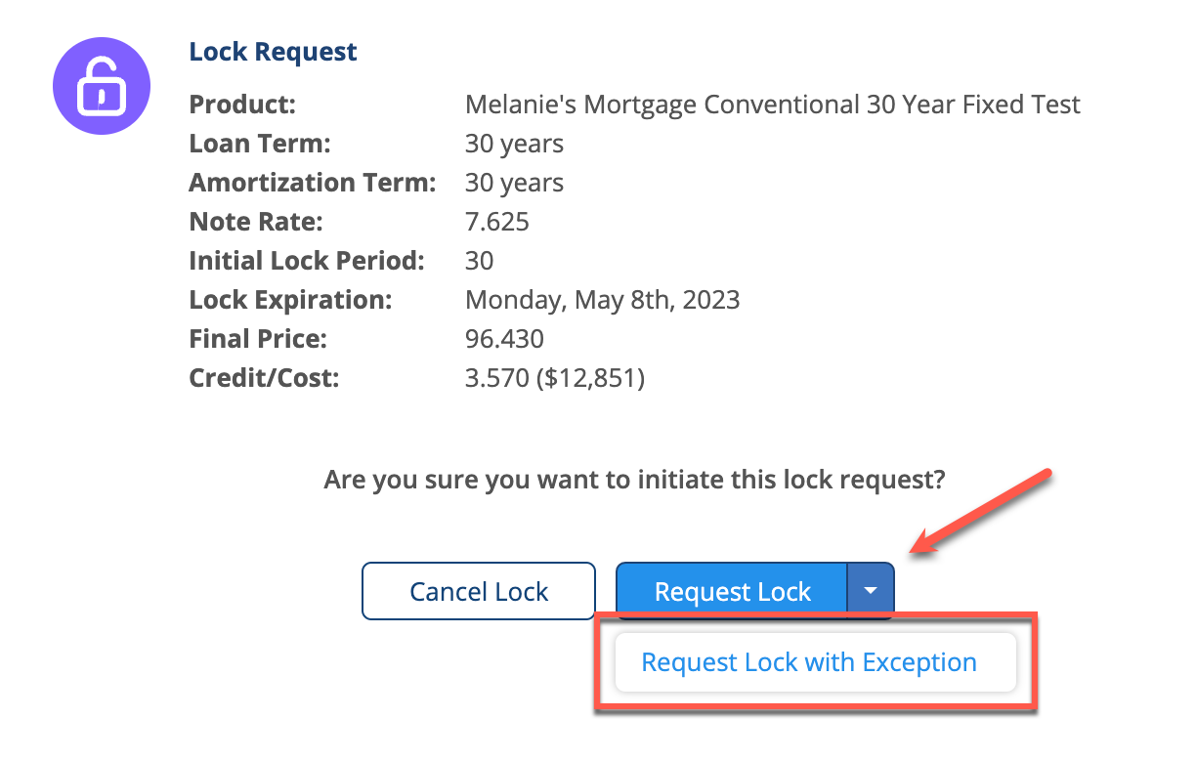

For post-lock exceptions, the user will see the Price Exception option when they log into FLEX through the LOS.

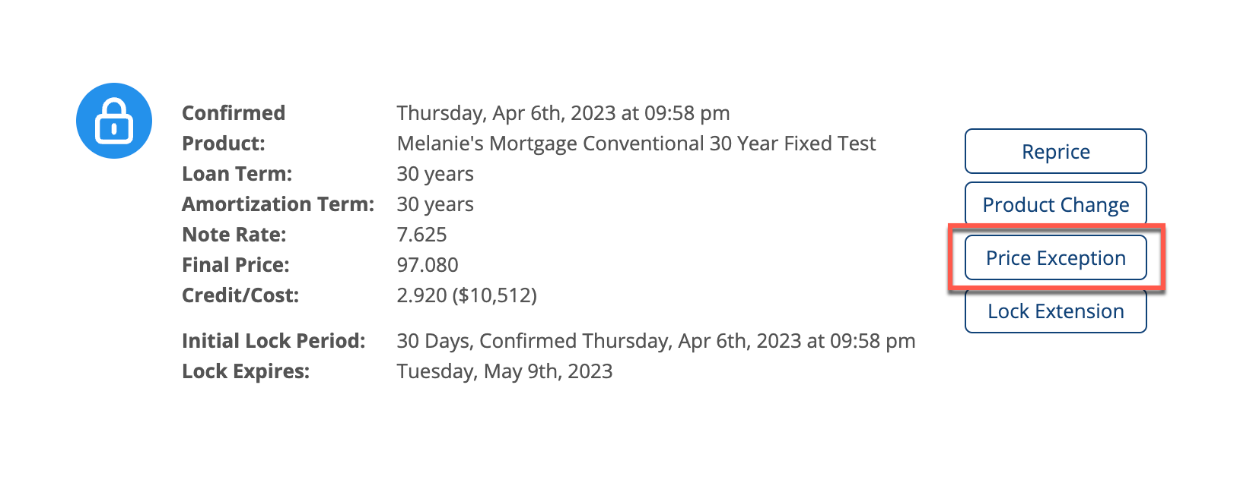

Note: Any data changes inside the LOS will automatically flow into FLEX. If there are data changes that need to be reconciled, a Forced Reprice message will display and the user will need to Reprice the loan before proceeding with the Price Exception.

Select Price Exception and the user will be directed to the Price Exception request page.

Lock Request with Exception:

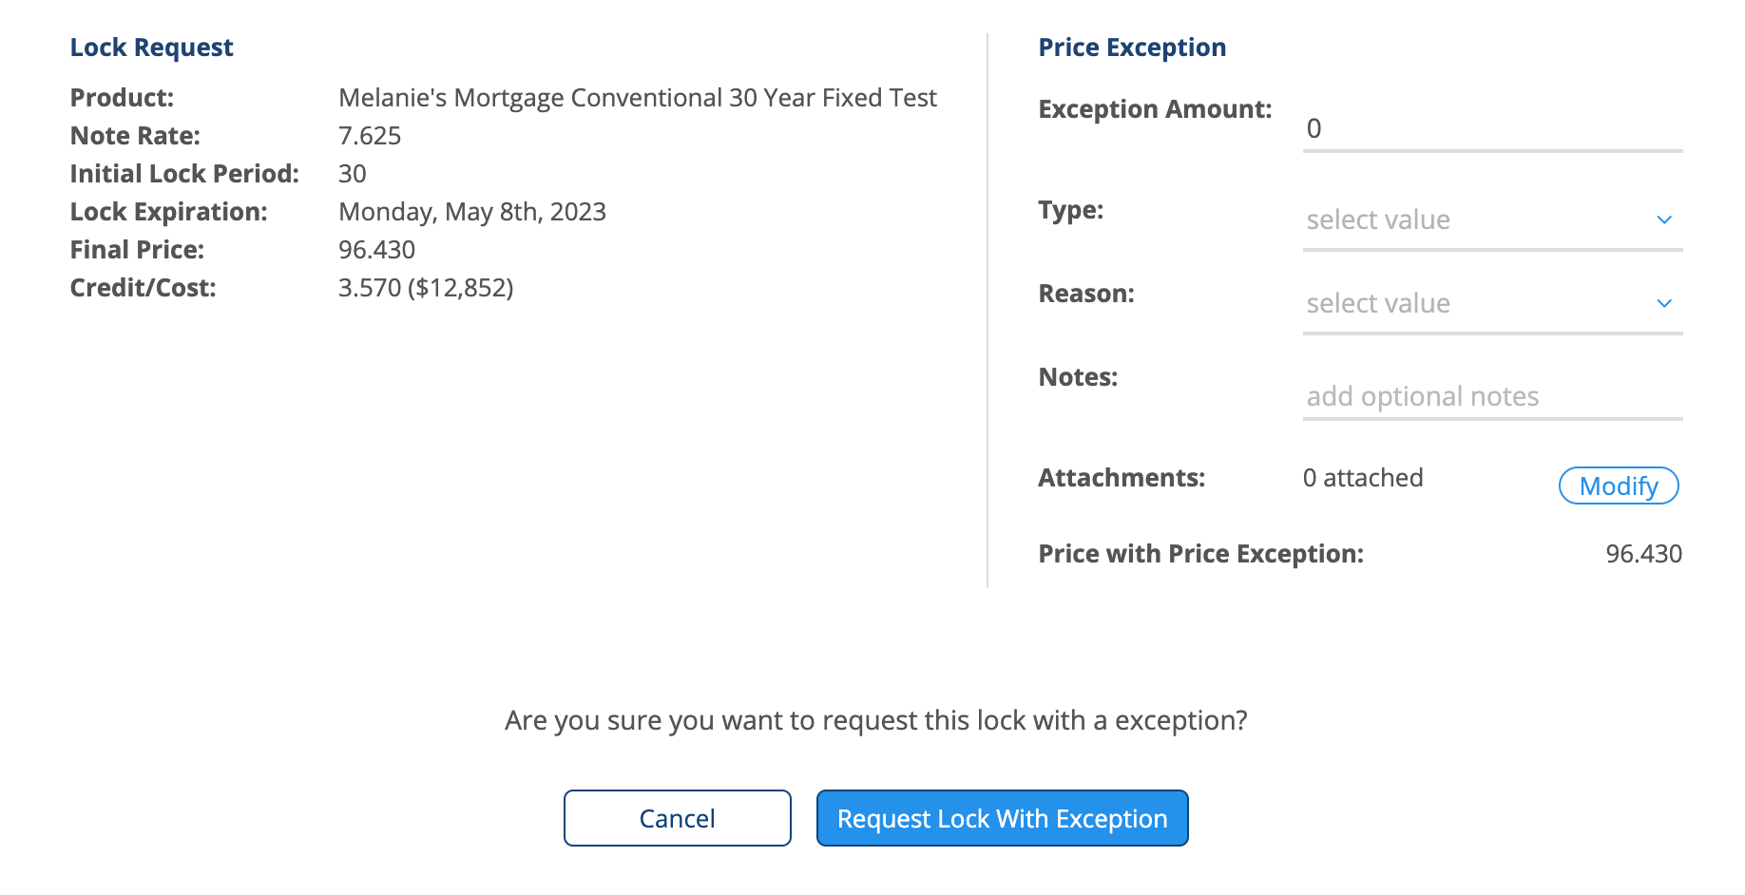

Post-lock Price Exception:

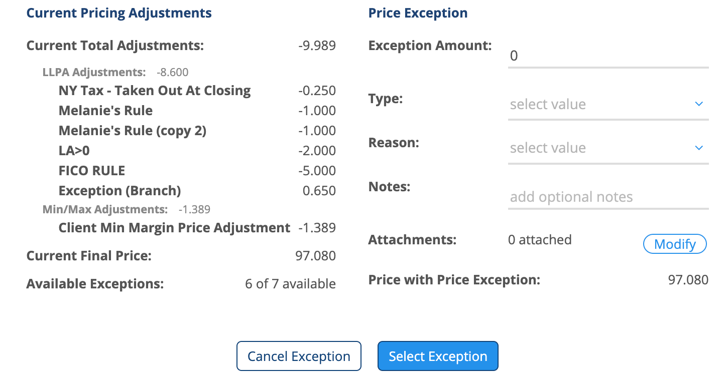

The user will enter in the Exception Amount, Type, Reason, and Notes, if applicable. Attachments are also available for uploading documents to support the Price Exception. The user will select Modify to upload documents.

The user can drag and drop or upload the documents.
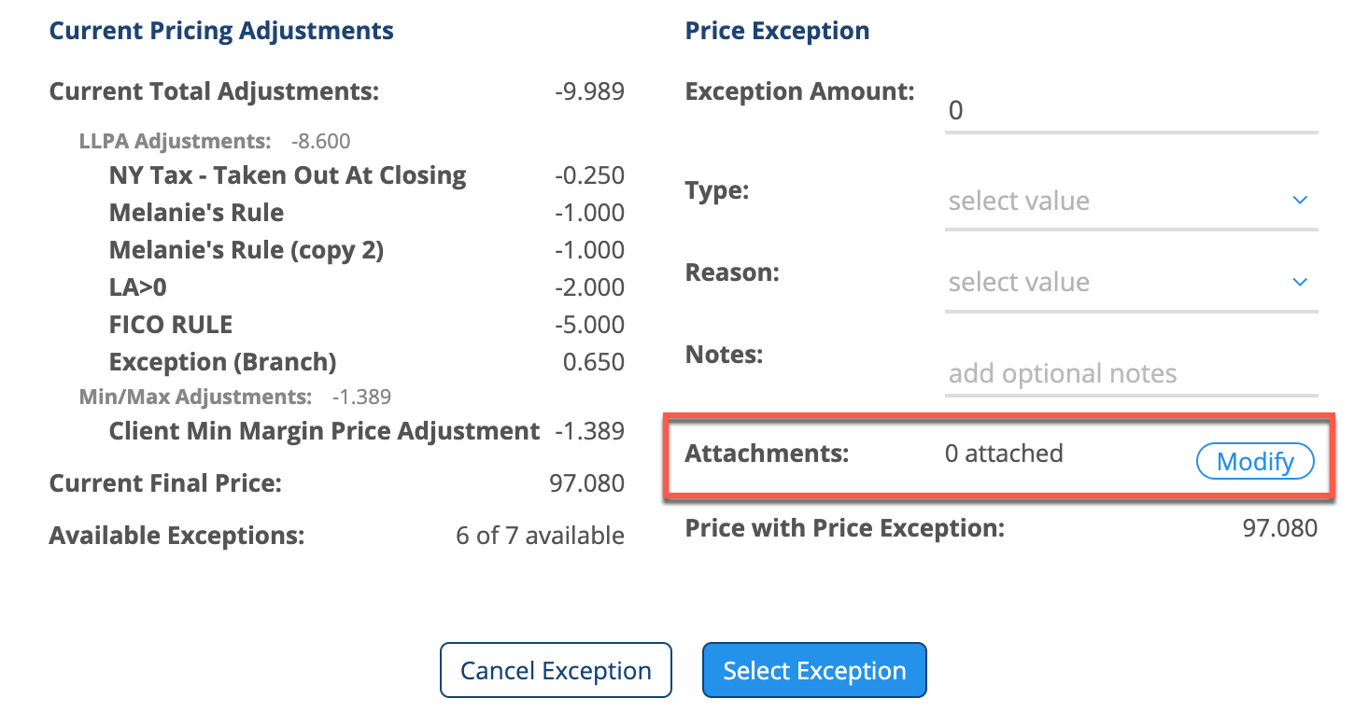

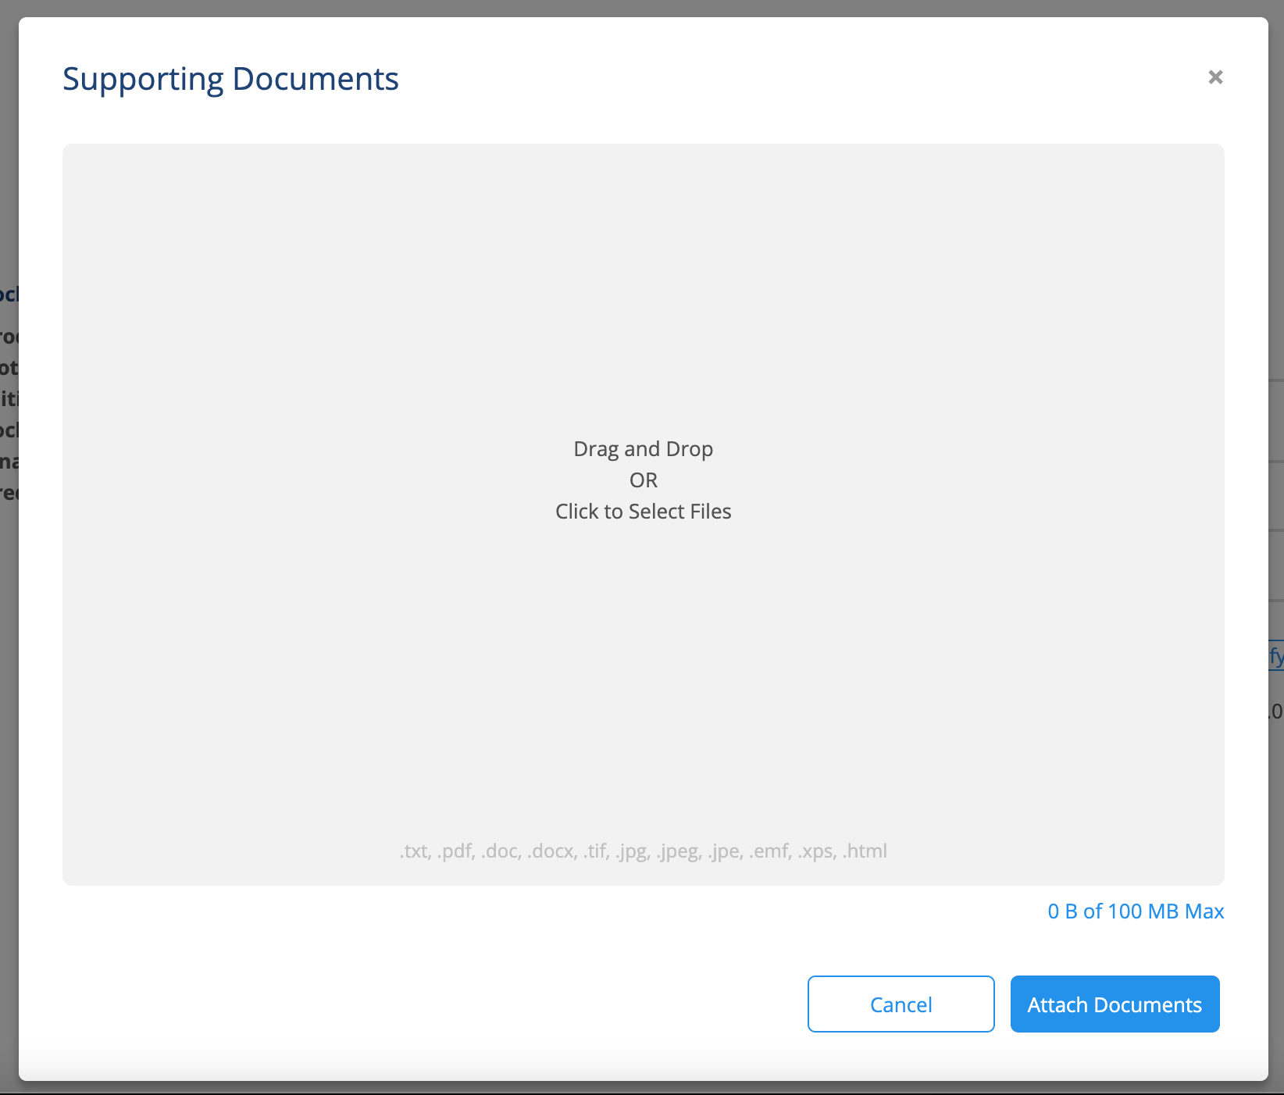

Once attached, documents can be easily removed by hovering over the document tile and selecting the X icon.
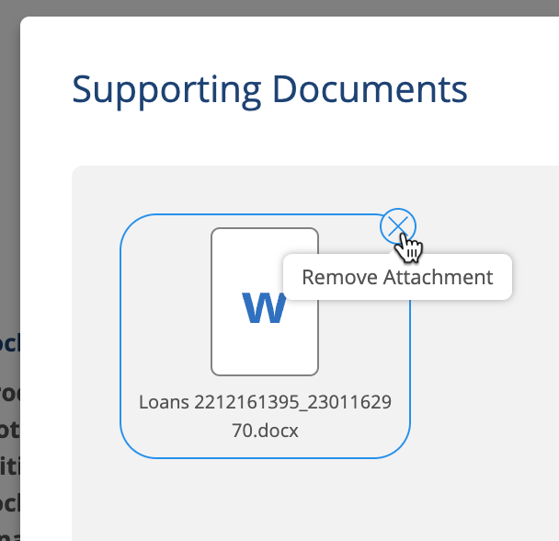

Note: Based on the exception amount and the company policy, attachments may be required.

If required and the document is not uploaded when submitting a Price Exception, an error message will appear to notify the user that supporting documentation is required as shown in the screenshot below.

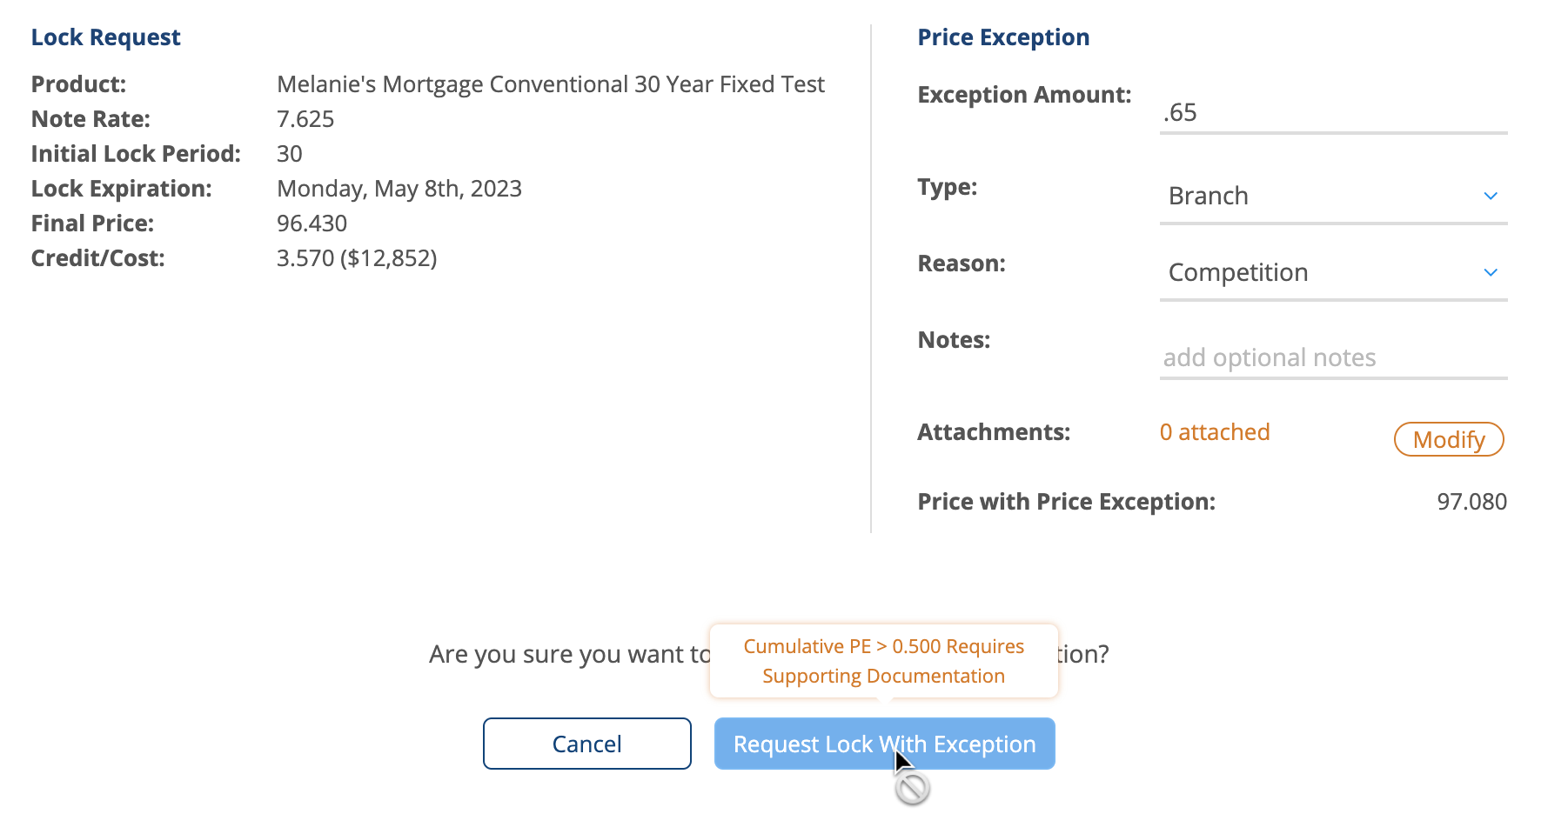

The user can select the Cancel button if they do not wish to move forward with the exception. This will take them back to their landing page where they can select any available post-lock action or the initial lock, depending on the workflow.

If price exception policies are configured to be auto accepted, the Price Exception will be automatically accepted and the updated data will be sent back to the LOS.

Note: Please make sure to exit the loan so the updated data writes back to the LOS.

