USER GUIDE:
How to Request a Lock Extension in the FLEX PPE
—

Select FLEX as the PPE option inside the LOS to launch into FLEX with the selected loan.

Upon login to FLEX, the user will see the Lock Extension option to extend the lock based on any data changes.

Note: Any data changes inside the LOS will automatically flow into FLEX. If there are data changes that need to be reconciled, a Forced Reprice message will display and the user will need to Reprice the loan before proceeding with the Lock Extension.

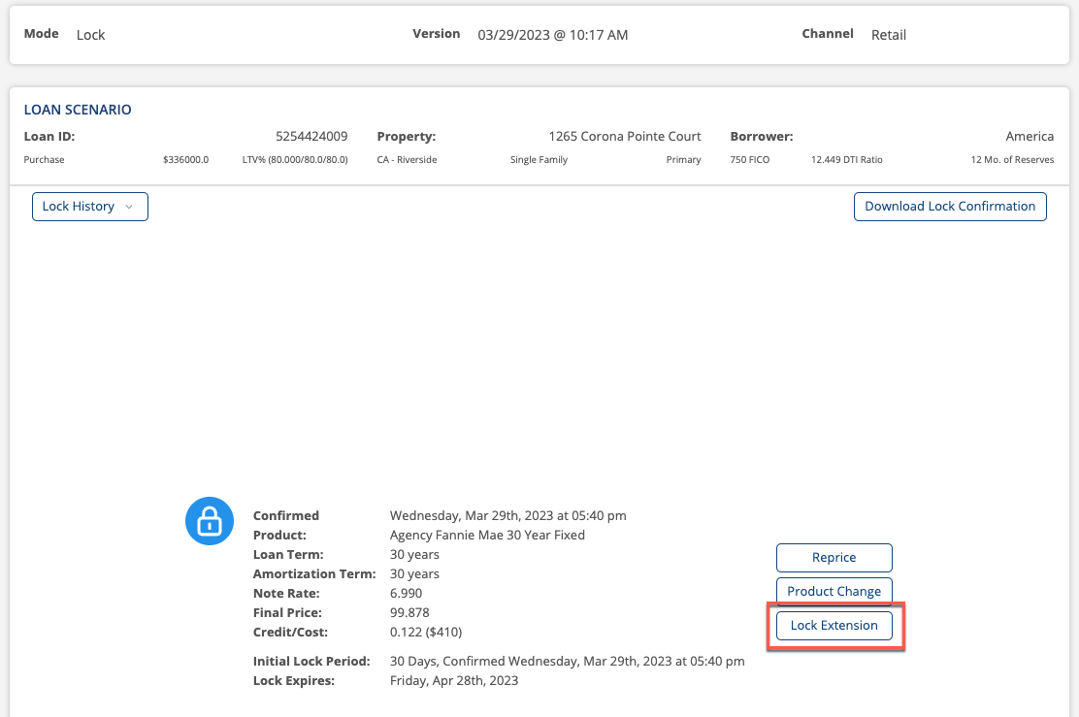

Select Lock Extension and the user will be directed to the Lock Extension request page.

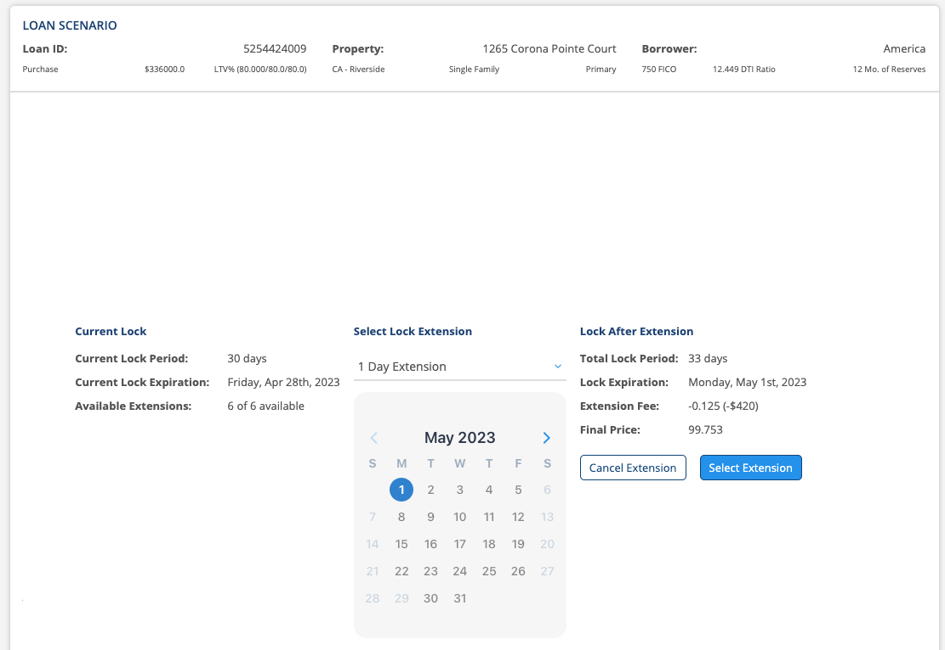

The user will select the dropdown list to find the number of days they would like to extend. Once selected, the Lock After Extension data will be updated to reflect the extension days selected. Once updated, users will select the Select Extension button.

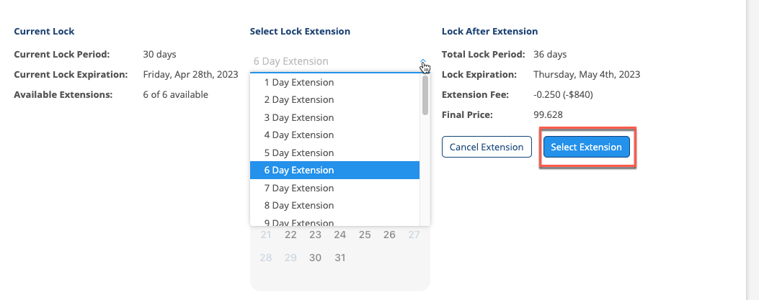
The user will then review the updated data and select the Request button to request the extension.

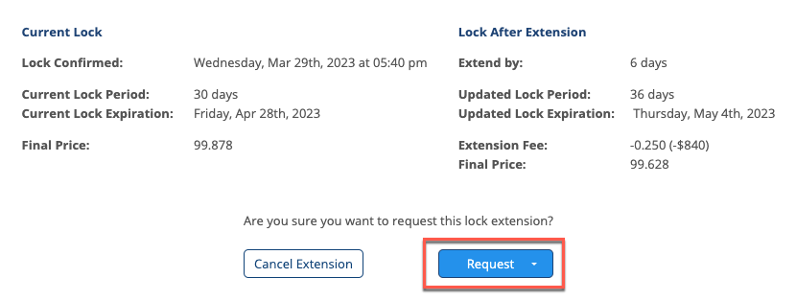

The user can select the Cancel Extension button if they do not wish to move forward with the extension. This will take them back to the previous landing page where they can select any available post-lock action.

If lock extension policies are configured to be auto accepted, the Lock Extension will be automatically accepted and the updated data will be sent back to the LOS.

Note: Please make sure to exit the loan so the updated data writes back to the LOS.

