USER GUIDE:
How to Request a Lock in the FLEX PPE
—

Select FLEX as the PPE option inside the LOS to launch into FLEX with the selected loan.

Upon login to FLEX, the user will be taken to the search results page and if all required fields to run the search are available, products will be evaluated and returned automatically.

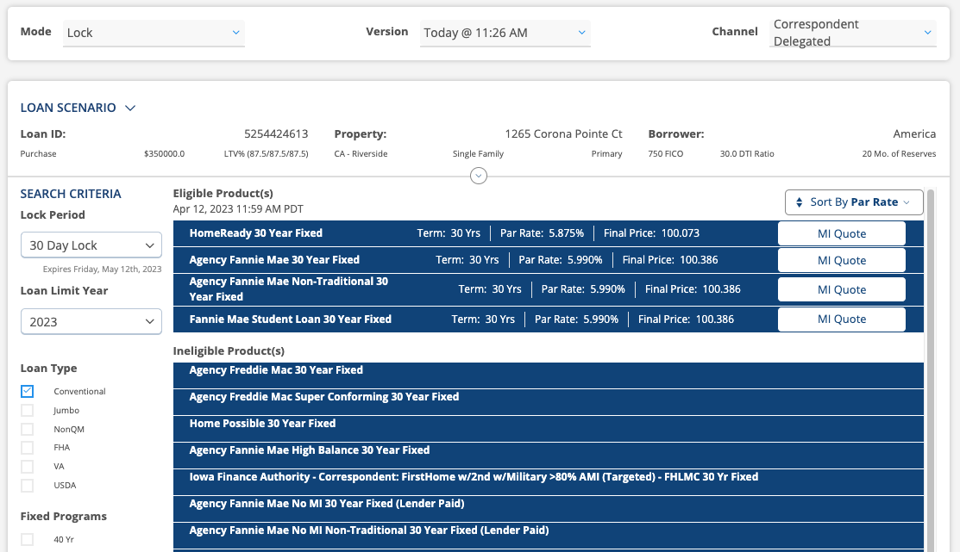

If there is a required field that does not have a value, the search results will not display any products in the results, and the user will need to select the small arrow at the top-middle of the page to open the Pricer form and fill in the required fields.

Once completed, the user will select the Get Pricing button to evaluate product eligibility and pricing.

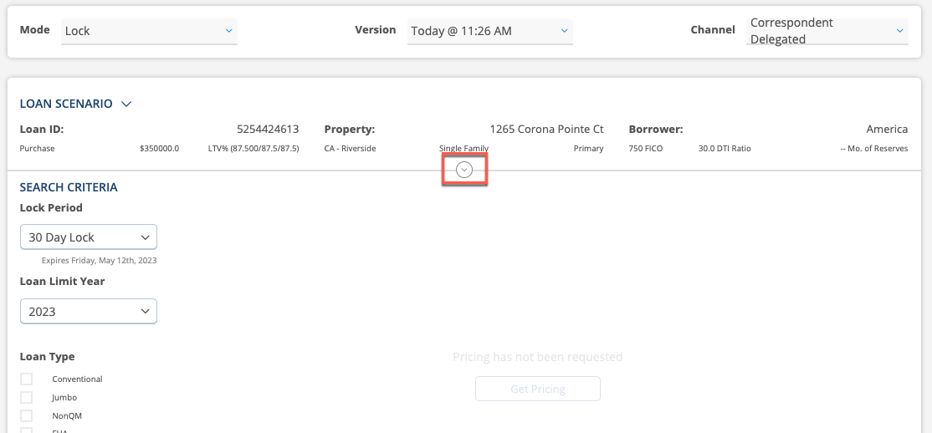

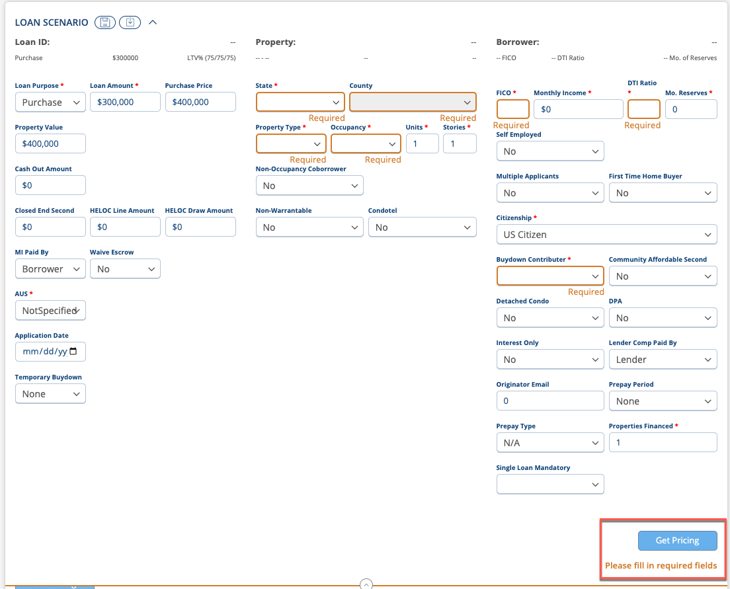

Note: If a field is locked down, the user will need to exit FLEX and make the updates inside the LOS and then launch back out to Polly to price the loan with the updated values.

Once the fields above are updated, click Refresh Pricing to see updated price results.
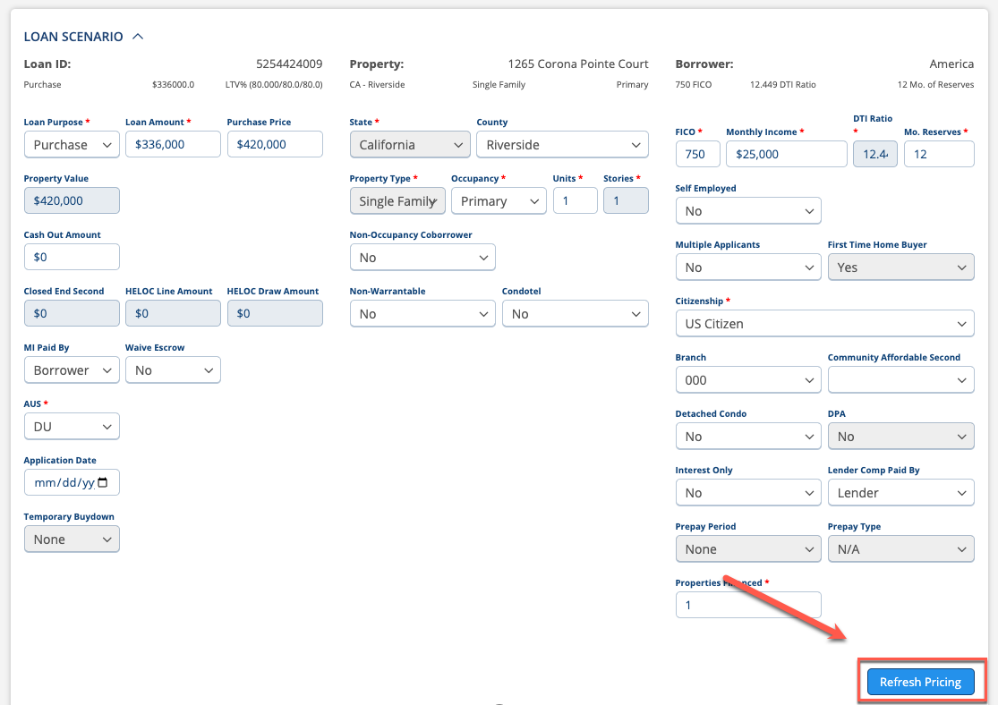

Products will return as eligible and ineligible, with the best priced product, closest to par auto expanded as the first eligible option and the par rate/price checked by default.

Select the blue bar that contains the product name and par pricing information to expand/collapse the rate grid.

The Search Criteria section to the left of the search results will allow the user to change additional parameters based on what type of product they are searching for in the results. Once updated, select the Refresh Pricing button.

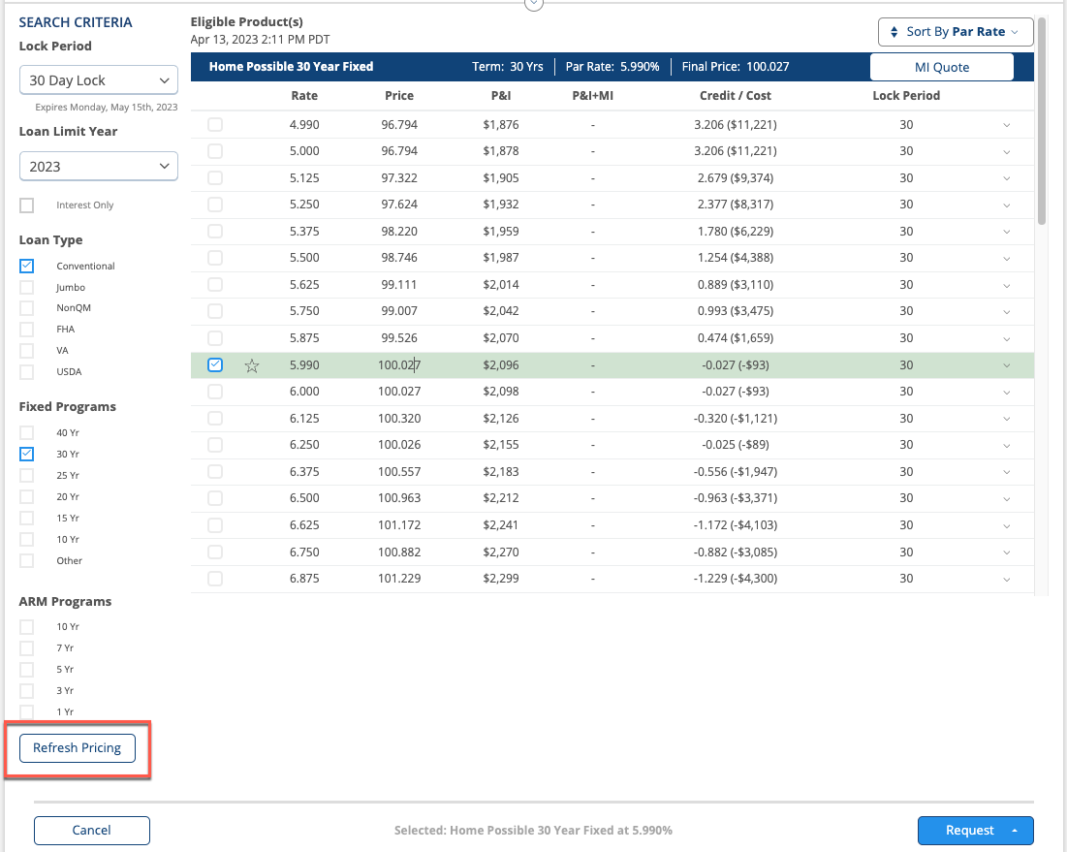

Select any row of pricing data with the rate grid to expand the LLPA section. The user will select the checkbox next to the rate they would like to request the lock on and then select the Request button. This will open up two additional options, Lock and Float.

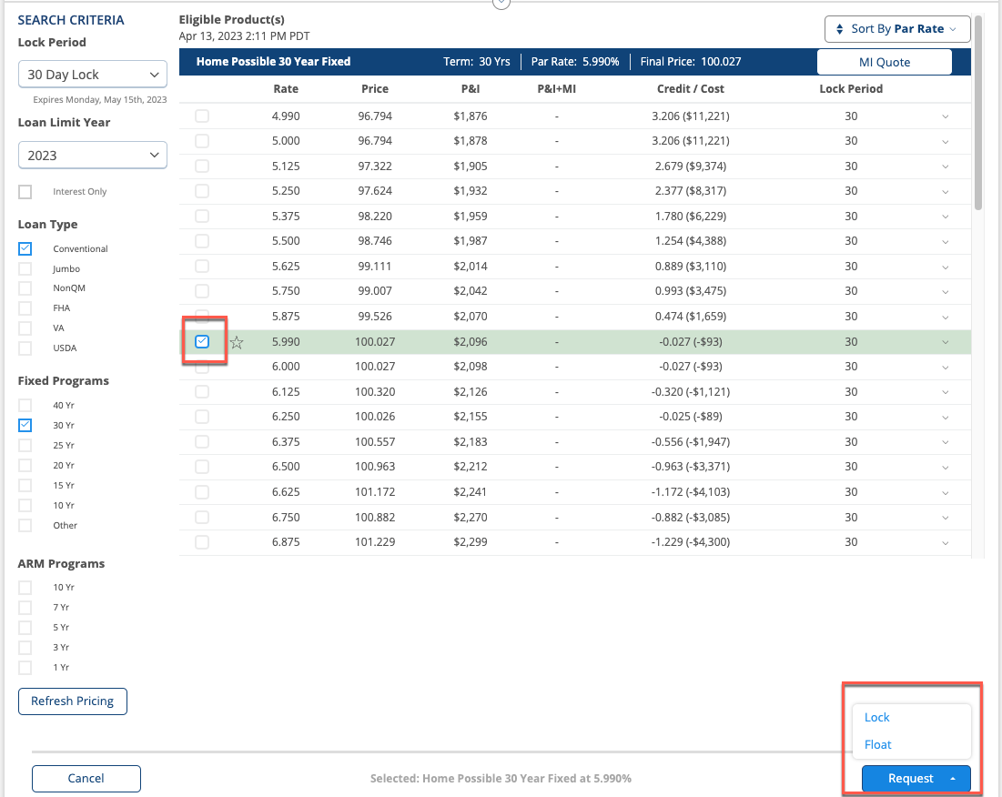

If the user is not ready to request the lock, but would like to save the pricing data back to the LOS they should select the Float option. If the user is ready to request the lock, they should select the Lock option.

After selecting Lock, the user will land on a page to review the product data. At this point they can Cancel Lock, Request the Lock or Request with an Exception.

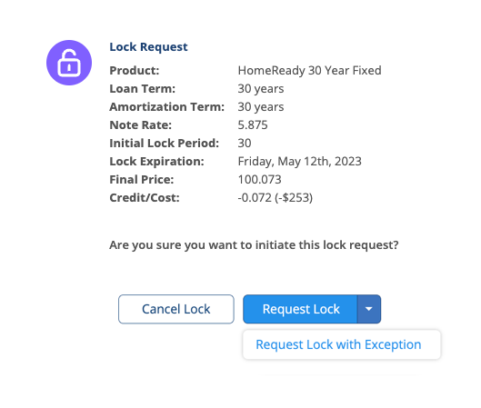

Select the applicable option to request the lock. For more information regarding Price Exception Functionality, please use the Price Exception User Guide.

Note: Please make sure to exit the loan so the updated data writes back to the LOS.

